**RPG PROJECT**

This report follows the same sequence of instructions as the 8.1 Role Playing Game OneNote document. Ensure you complete tasks in order.

(Please complete tasks 1 & 2 before starting the below)

**3.** **Add comments to the program** – Highlight areas of the code and explain what is happening. Once you have commented your code, use snipping tool to provide evidence of this and give some examples below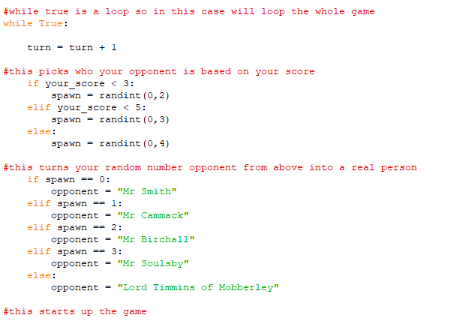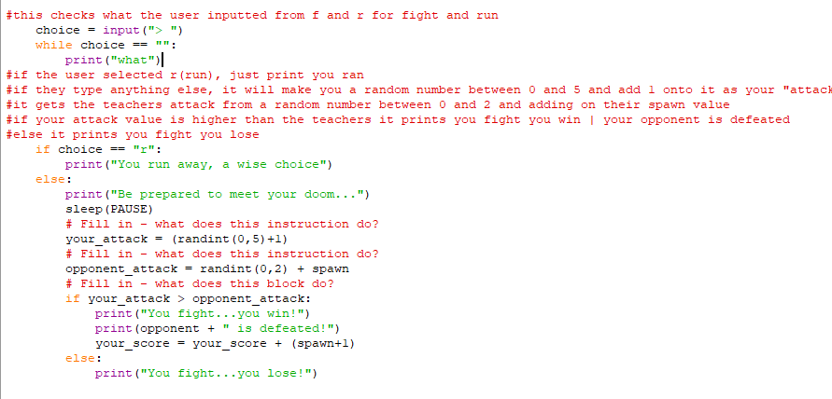

**4. Describe the program** – In your own words:

a. Describe what you think the program does and how it does it.

b. Describe at least 2 good points about the program.

c. Describe at least 3 limitations of the program – What could be better?

a) the program is a role-playing game that is run based of random numbers, and the more you play, the more options that open up and more likely you are to win

b) it is engaging and fun, it has a good selection of characters to defeat

c)there could be more user interaction, it could be more visually appealing, maybe customizable options would also make the game more interesting

**5. Improvements** – Describe how this program could be improved – Make a list of at least 5 requirements that your improved program will include.

Improvement 1 – Better graphics possibly pygame

Improvement 2 – Implement a lives system - done

Improvement 3 – Add more choices / user interaction maybe more options instead of fight or run

Improvement 4 – Make it a 2 player game

Improvement 5 -

**6. MODIFICATIONS**

**You will use this space to provide documentation and evidence for all of your modifications.**

You show include:

**Suitable comments within the program**

**Screenshots of your completed code**

**Screenshots of the program running**

**Screenshots demonstrating you have tested your program including a description outlining what is you are testing.**

**Screenshots of the Lists in your program**

**Lists:**



**Use:**



**Screenshots of the Sub program in your program**

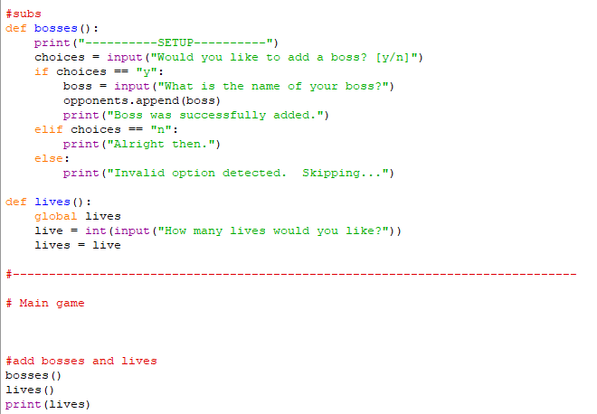

**Screenshots of the file handling in your program running**

**7. Evaluation** – Evaluate your finished program against the requirements you set out at the start.

a. Describe what you have achieved, were there any limitations with what you wanted to achieve? Did you achieve what you set out to achieve?

b. How do you know? – Think about the requirements you set out and the modifications you wanted to implement against the finished project

c. What could you do next if you had further time? How would you do things differently?